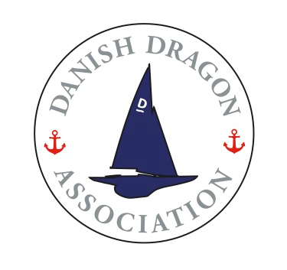

Oresund Dragon Championship

Royal Danish Yacht Club

Skovshoved Marina
8th – 9th May 2021
Notice of Race
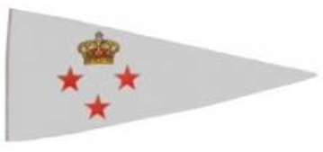 | 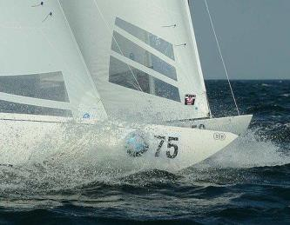

Royal Danish Yacht Club, in cooperation with the Danish Dragon Association, has the pleasure of inviting you to the Oresund Dragon Championship 2021.

This event is about sailing, nothing more, nothing less. Sailing so everyone is tuned in for the Danish Championship the following weekend

The notation ‘[DP]’ in a rule in the NoR means that the penalty for a breach of that rule may, at the discretion of the protest committee, be less than disqualification and cannot form basis for a request for redress.

The sailing instructions will consist of the instructions in RRS Appendix S, Standard Sailing Instructions, and supplementary sailing instructions available on the Manage2Sail website relevant for the event:
https://manage2sail.com/en-US/event/911c5e68-361f-42ff-8932-9cd273641dcf#!/

RULES
  - The regatta will be governed by the rules as defined in The Racing Rules of Sailing.
  - The applying prescriptions of the Scandinavian Sailing Association and the Danish Sailing Association will be incorporated into the sailing instructions.
  - The following other documents will apply: Statutes for Danish Championships in Sailing.
  - Racing rule(s) will be changed as follows:
    - The preamble to Part 4 will be changed, to state that the obligation to wear personal buoyancy when signal flag Y is displayed not only applies while racing.
    - Rules 35, A4 and A5.1 will be changed to state that boats failing to finish within 15 minutes after the first boat sails the course and finishes, will be scored DNF.
    - Rules A4 and A5.1 will be changed to state that boats starting later than four minutes after the starting signal will be scored DNS
    - Rule 44.1 will be changed to that the two-turn penalty is replaced by a one-turn penalty.
    - Rule 60.1(a) will be changed to state that a competitor cannot protest another boat or competitor for breaches of specific parts of the sailing instructions.
    - Rule 62.1(a) is changed so that a deviation from the sailing time for the first boat to finish cannot form basis for a request for redress.
The changes will appear in full in the sailing instructions. The sailing instructions may also change other racing rules.
  - If there is a conflict between languages the English text will take precedence.

ADVERTISING
  - Competitor advertising will be restricted to Category A.
  - Boats may be required to display advertising chosen and supplied by the organizing authority.

ELIGIBILITY AND ENTRY
  - The regatta is open for all owners of Dragons, which hold valid measurement certificates.
  - Eligible boats may enter by completing the entry form
https://manage2sail.com/en-US/event/911c5e68-361f-42ff-8932-9cd273641dcf#!/

CLASSIFICATION
This section will not be in use.

FEES
  - Required fees are as follows: Entry fee: 1000 DDK.
Because of Corona precautions, no dinner will be provided. There will be after-race-beer and hotdogs from a hot dog stand.
Payment via http://Manage2sail.com only.

SCHEDULE
  - Registration at race office on:
Friday, 7th of May at: 15:00 to 19:00
Saturday, 8th of May at: 08:00 to 09:30
  - Measurement/inspection:
No measurement/inspection will take place.
  - Dates of racing:
Saturday, 8th of May and Sunday, 9th of May 2021
  - Number of races:
Day: Number of races planned: First warning signal of the day:
Saturday As many races as possible 11.00 hrs. Sunday As many races as possible 10.00 hrs.
  - After finishing a race, a new race will be started as soon as possible.
  - On the first day of the regatta, no warning signal will be made after 16.00 hours, on the last day of racing no warning signal will be made after 15:00.

MEASUREMENTS
No measurements will be required.

SAILING INSTRUCTIONS
The sailing instructions will be available on
https://manage2sail.com/en-US/event/911c5e68-361f-42ff-8932-9cd273641dcf#!/
May 1st, 2021 at the latest.

VENUE
  - Location of the regatta harbor:
The regatta harbor will be Skovshoved Marina, Skovshoved Havn 5, 2920 Charlottenlund.

  - Location of the racing areas:
Courses will be sailed on the waters east of Skovshoved Marina.

THE COURSES
The course will be a windward/leeward course with a gate in front of the start and finish at the bottom of the course.
A diagram showing the course including information of the approximate sailing time will be a part of the Sailing Instructions.

PENALTY SYSTEM
  - Rule 44.1 is changed so that a two-turn penalty is replaced by a one-turn penalty.
RSS A5.3 applies.
  - Due to Corona restrictions a distance between sailors from different boats of 2 m needs to be kept during the event on shore. [DP]

SCORING
  - The scoring system is as follows: Low Point System.
  - 4 races are required to be completed to constitute a series.
  - (a) When fewer than 5 races are completed, a boat’s series score will be the total of her race scores.
(b) When 5 or more races are completed, a boat’s series score will be the total of her race scores excluding her worst score.

SUPPORT BOATS
Support boats shall be marked with a club burgee. [DP]

HAUL-OUT RESTRICTIONS
Boats shall not be hauled out during the regatta except with and according to the terms of prior written permission of the race committee. [DP]

RADIO COMMUNICATION
Except in an emergency, a boat shall neither make radio transmissions while racing nor receive radio communications not available to all boats. This restriction also applies to mobile telephones. [DP]

The race officer intends to broadcast race management information regarding the courses, the start, recalls etc. to the fleet by VHF Radio.

PRIZES
Prizes will be awarded for the first three boats.
Due to Corona restrictions, prizes can be picked up from the race office, no prize ceremony will take place.

DISCLAIMER OF LIABILITY
Competitors participate in the regatta entirely at their own risk. See rule 4, Decision to Race. The organizing authority will not accept any liability for material damage or personal injury, or death sustained in conjunction with or prior to, during, or after the regatta.

INSURANCE
Each participating boat shall be insured with valid third-party liability insurance with a minimum cover of DKK 16.000.000 per event or the equivalent.

19 FURTHER INFORMATION
For further information please contact: Royal Danish Yacht Club.
Mail: Ladefoged.2970@gmail.com or phone: +45 26778900

Event Manager: Claus Ladefoged, Royal Danish Yacht Club
Race Officer: Michael M. Andersen, Royal Danish Yacht Club

